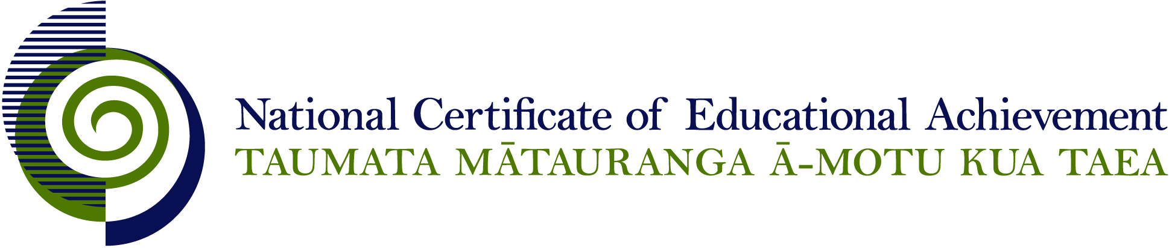

NCEA Level 2 Physics

Conditions of Assessment

General Information

Subject Reference | Physics
Domain | Physics
Level | 2

Conditions of Assessment

These Conditions provide guidelines for assessment against internally assessed Achievement Standards. Guidance is provided on:
- specific requirements for all assessments against this Standard
- appropriate ways of, and conditions for, gathering evidence
- ensuring that evidence is authentic.

Assessors must be familiar with guidance on assessment practice in learning centres, including enforcing timeframes and deadlines. The NZQA website offers resources that would be useful to read in conjunction with these Conditions of Assessment.

The learning centre’s Assessment Policy and Conditions of Assessment must be consistent with NZQA’s Assessment Rules for Schools with Consent to Assess. This link includes guidance for managing internal moderation and the collection of evidence.

Gathering Evidence

Internal assessment provides considerable flexibility in the collection of evidence. Evidence can be collected in different ways to suit a range of teaching and learning styles, and a range of contexts of teaching and learning. Care needs to be taken to allow students opportunities to present their best evidence against the Standard(s) that are free from unnecessary constraints.

It is recommended that the design of assessment reflects and reinforces the ways students have been learning. Collection of evidence for the internally assessed Standards could include, but is not restricted to, an extended task, an investigation, digital evidence (such as recorded interviews, blogs, photographs, or film), or a portfolio of evidence.

Effective assessment should suit the nature of the learning being assessed, provide opportunities to meet the diverse needs of all students, and be valid and fair.

Ensuring Authenticity of Evidence

Authenticity of student evidence needs to be assured regardless of the method of collecting evidence. This must be in line with the learning centre’s policy and NZQA’s Assessment Rules for Schools with Consent to Assess.

Ensure that the student’s evidence is individually identifiable and represents the student’s own work. The evidence must be an accurate reflection of what the student independently knows and can do, according to the Standard being assessed. This includes evidence submitted as part of a group assessment, evidence produced outside of class time or without assessor supervision, and evidence produced with any use of generative artificial intelligence tools (GenAI). GenAI use should be carefully considered in the context of the Standard being assessed and its Conditions of Assessment, discussed with students before the assessment, and its use must be acknowledged. For example, an investigation carried out over several sessions could include:
- teacher guidance on the nature and extent of acceptable GenAI use, if any
- assessor observations and conversations
- meeting with the student at set milestones or checkpoints
- the student’s record of progress, such as photographic entries or any GenAI prompts used.

Specific Information for Individual Internal Achievement Standards

Achievement Standard Number | 91168 Physics 2.1
Title | Carry out a practical physics investigation that leads to a non-linear mathematical relationship
Number of Credits | 4
Version | 2

Assessment of this standard could involve a single assessment event or a portfolio of experimental reports (each of which is a complete investigation).

Raw data may be collected and processed in small groups but the teacher needs to ensure that there is evidence that each student has met all aspects of the standard.

The assessor can determine the time allowance for the assessment, as this is dependent on the situation.

Achievement Standard Number | 91169 Physics 2.2
Title | Demonstrate understanding of physics relevant to a selected context
Number of Credits | 3
Version | 2

Contexts may be general, for example: radiocarbon dating, nuclear medicine, sports science, the motor car or specific for example Compact Discs, diagnostic X-rays, car speedometer.

Students could either be given the context they are required to address or they could select it for themselves. If the latter applies the context selected should be approved by the teacher.

Data may be collected in small groups but the teacher needs to ensure that there is evidence that each student has met all aspects of the standard.

Evidence could be collected by, but is not limited to, the following methods:
- written report
- oral presentation
- multimedia presentation
- poster

The assessor can determine the time allowance for the assessment, as this is dependent on the situation.

Achievement Standard Number | 91172 Physics 2.5
Title | Demonstrate understanding of atomic and nuclear physics
Number of Credits | 3
Version | 2

Students could be given a self-directed open-ended activity in which they demonstrate understanding of the phenomena, concepts or principles as described in Explanatory Note 4 of the standard in a given situation. The situation chosen must be broad enough to allow for sufficient phenomena, concepts or principles to be included.

Evidence could be collected by, but is not limited to, the following methods:
- written report
- oral presentation
- multimedia presentation
- poster.

The assessor can determine the time allowance for the assessment, as this is dependent on the situation.

